**Step 1:-** download “[Xerces C++ 3.1.1 - x86-windows-vc-10.0.zip](http://www.globalish.com/am/xerces/c/3/binaries/xerces-c-3.1.1-x86-windows-vc-10.0.zip)” from <http://xerces.apache.org>.

Unzip it in your system directory. E.g. I unzip it in this path “I:\Personal Data”.

**Step 2:-** Open your visual studio 2010 C++ solution where you want to use Xerces’s parser.

Now do the following :-

**Step 3:-** Right click on your project, select C/C++ tab and give Xerces’s Include folder path in Additional Include Directory Column.

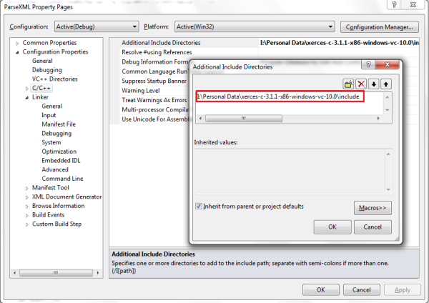

**Step 4:-** Right click on your project, select Linker tab and give Xerces’s lib folder path followed by “xerces-c_3.lib” file in Additional Dependency Column.

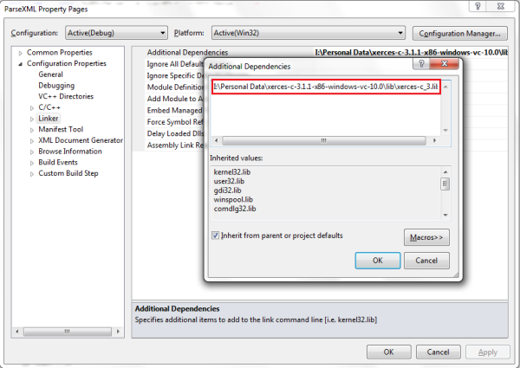

**Step 5:-** Include Xerces header files whichever you require. Include Xerces namespace also, i.e. “XERCES_CPP_NAMESPACE_USE”.

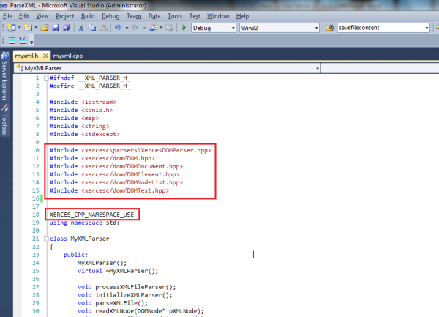

**Step:-6** P the Xerces DLL into the solution directory (or in the same location as the executable).

Now you will be able to use Xerces APIs in your solution. For further information on Xerces APIs go to given path for detailed description of Xerces APIs.

<http://xerces.apache.org/xerces-c/apiDocs-3/functions.html>